Finance Report
12 months to March 21

Overall, income has risen slightly against previous expectations and routine expenditure is slightly below expectations, even with additional expenses incurred related to COVID.
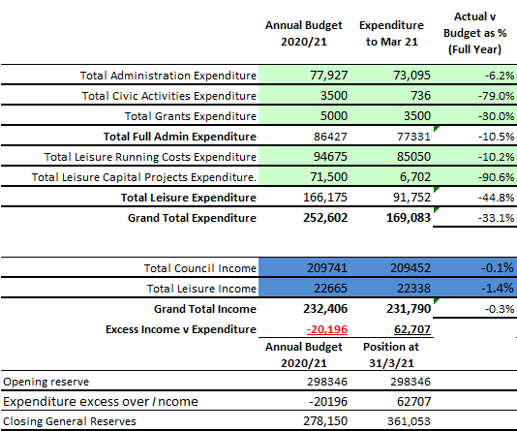

The major item that requires highlighting is Leisure Capital spend, where only £7k was spent in the year compared to an annual budget of £72k plus an expected roll over from 2019/20 related to Cheapside. The result is that expenditure is below income by £63k and reserves have increased by this amount, whereas the plan for the current year was to utilise reserves of £20k.

The overall reserves are shown below. The overall at £361k may seem, at first sight, high but it has been built up to cover many items, as detailed.
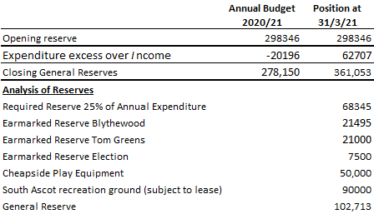
In addition, the separate CIL reserve stands at £308k, as per page 2 over.

R.Wood 18.05.21

Appendix CIL for year to 31/3/21

