BACKING PAPER
Leisure & Cultural Committee Meeting, Tuesday 28th September

Provision of Wheelie Bin on High Street
The Litter Squad have requested provision of a large litter bin to dispose of collected rubbish. We currently have no system for volunteers to dispose of rubbish, at present they take it home with them to put in their own bin which makes it difficult for less physically able people to join in. Several regular pickers live in areas with communal bins and now litter is to be collected every two weeks are unable to fill the bins with the bags they collect. So far we have no agreement with the Borough on a solution for the litter we collect and hope the Parish Council can step in since these volunteers are providing a great public service.

We have three regular routes that converge on the high street so it makes sense for the bin to be located there. I have sought provisional agreement from the Racecourse that the bin could be placed on their land on the understanding that it is the Parish Council’s responsibility to see that it is kept emptied. Possible options are car park 6 or car park 3. The bin would be fitted with a combination lock and those collecting can phone in advance for the combination.

Quote
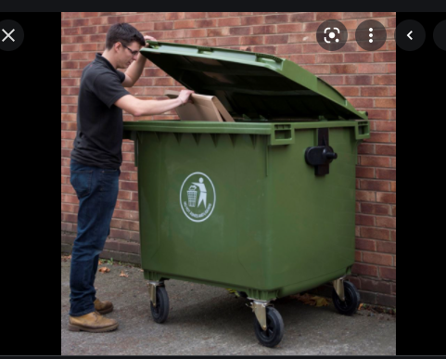
Bin price: £6.00 a month bin rental price. £72 per annum
Per lift: £15.32. £367.68 per annum
Duty of Care Fee* £4.95 monthly (£59.04)
Cost to Parish Council: £498.72 per annum

Weight allowance of 75KG per bin, per lift, and a surcharge of £0.18/KG if the agreed weight is exceeded.

Cost calculated based on 1x 1100 liter bin emptied every 2 weeks based on current needs.

*(Duty of Care ensures the legality of transferring waste between two companies and covers the administration of paperwork to ensure we are all legal).

Proposal
Parish Council to provide a Litter Bin for the use of the Litter Squad only
Cost: £498.72 per annum

