Finance Report
4 months to July 21

On the expense side, minimal Capital spend has been made and no other significant unplanned expense has been incurred. 50% of the precept has been received but other income such as pitch fees, hanging basket income, burial fees are all well behind plan.
As a result reserves continue to grow to cover future expenses.
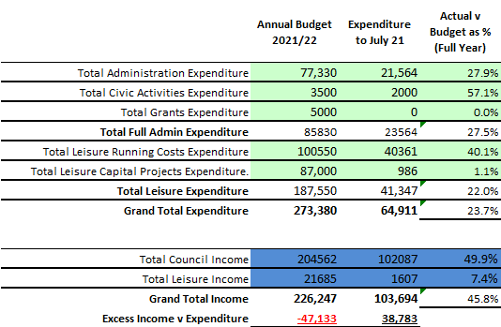

Civic Activities shows the cost of the ANPR contribution previously agreed and Leisure Running costs includes £14k (annual payment in advance) related to hanging baskets resulting in the proportionately high expense above.

Forecast expense going forward, expects expense for additional member of staff, unbudgeted but approved by Council £5k this year and £10k annually, plus £5k for library running costs. No other untoward expense is envisaged and it is hoped to keep within the budgeted use of reserves of £47k to cover costs.
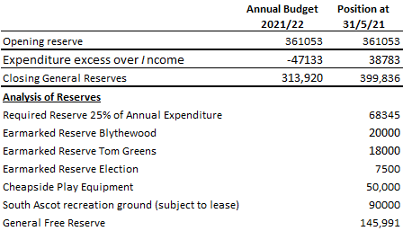

In addition, there is a CIL reserve of £412k against which no commitment have been agreed.

R Wood 06.09.21

