Platinum Jubilee Party in the Park Thursday June 2nd– 2021
Introduction
The following is a draft programme for “a Jubilee Party in the Park”, an afternoon and early evening of family fun culminating with the lighting of the Jubilee Beacon at Victory Field, Recreation Ground, hosted and organised by Sunninghill and Ascot Parish Council.
Event overview
This is a free family public event with live musical entertainment and DJ’s. It will also feature full range of activities from family fairground rides, BBQ and hot food concessions, a beer tent, supported by a range of popular activities and local stalls. Additional benefit will be to invite and showcase the many activities, schools, clubs and organisations that operate within the environs of our parish. (Opportunities for commercial sponsorship may also be explored).
Suggested Stage Schedule –
- 1.00pm – 5:30 pm: Arrivals and set up, stage, attractions, stalls, etc.
- 5:30pm – 6:15 pm: local bands and warm up music (mixed DJ set)
- 6:15pm – 8:15 pm: local bands and Feel good music, Remix of TOP 40’s
- 8:15pm – 9:05 pm: Ibiza Classics set, 90’s & Noughties
- 9:05pm – 9:30 pm: Lighting of Jubilee Beacon with accompanying speeches and ceremonial music. Choir and Piper.
- Event closes
- 9:30pm – 11.00 pm Stage de-rig and activities pack down, park clear or alternatively following morning, with security in place.
Example images of professional staging.
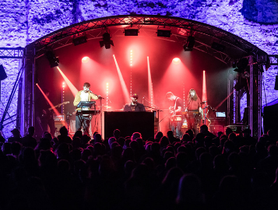
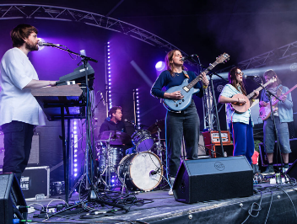
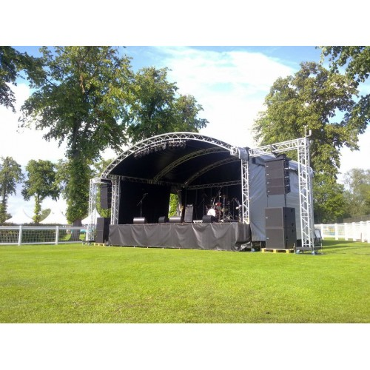

Scoping a project plan
Develop a project plan, with the budget costs based on previous events and then capturing the any additional costs. Set the funding required and seek sponsors.

Suggested work streams:

1. Event Logistics. Field Layout/Configuration Access & Egress Vehicle / People Movement & Management
2. Registration and purchase of Beacon
2. Marketing and Branding, Promotion, Advertising and Sponsorship
3. Neighbour relationship management
4. Event / Activities: Stalls, Local Charities. Refreshments ( interest from Ambulance Service, Fire and Police) etc.
5. Stage Set Up and De Rig
6. Power and Services, PAT etc & Beacon Lighting
7. Stage Programme Evening and Beacon Lighting
8. Emergency Hub: First Aid / Security / Lost Children / Site and Activity Risk Assessments
9. Responsibility Matrix
10. Financial reporting, invoices, insurances permissions etc.
11. Full Event Planning programme with mile stones.
12. Press/media
13. Safety Event management Plan

2019 Party in the Park
Costs / expenses £4,977.30 (SAPC Contribution £3,000)
Income generated £4,888.00

Approximate number of attendees: 2000.

Beacons registered to date Berkshire: Copper Horse. Windsor Great Park. Highclere Castle. Wraysbury Parish Council. Datchet Parish Council – Jubilee Green, Datchet. Seven Barrows Ltd – Faringdon Road Grass Gallops, Ferringdon.

