Finance Report
6 months to Sept 21

It is halfway through the year but we have received all the precept income from RBWM. One would expect expenditure to be 50% of budget at this stage. However, the level of leisure capital spend is very low and as a result in this six-month period there is excess income compared to expenditure and as a result reserves have increased by £113 K. A large part of the capital expenditure shortfall relates to Cheapside where the 50 K expenditure has only just been spent in October , however the balance still remains to be spent in the remainder of the year.
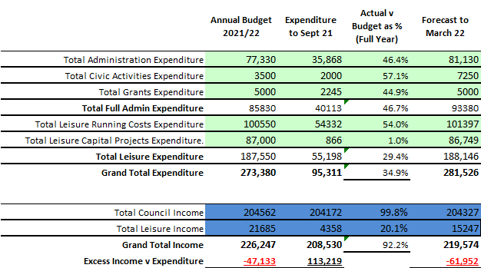

Expenses are forecast in the full year, by the clerk, to be in line with budget with the exception of additional staffing costs and the agreed library contribution (contained within Civic Activities). Regarding income, there are expected shortfalls in the area of hanging baskets income and burial fees. As a result, expenditure is expected to be in excess of income by £62K which will be funded from reserves, compared to a budgeted utilisation of £47K. As can be seen below there are sufficient reserves remaining to cover the shortfall.

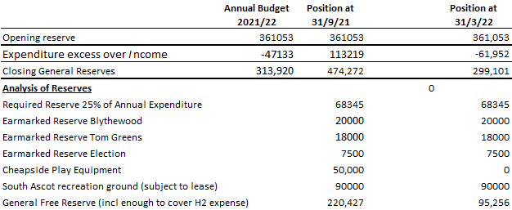

In addition, the separate CIL reserve stands at £412k but at the end of September.

R.Wood 24.11.21

