PROPOSED BUDGET 22/23
At the previous meeting on 30th Nov the forecast of expenditure to March 22 was detailed. The proposed budget has been based on this forecast adding or deleting items of expenditure which will not be planned in both years.
Set out below is a summary resulting budget for next year (the circulated Excel file contains the detailed breakdown on a line-by-line basis)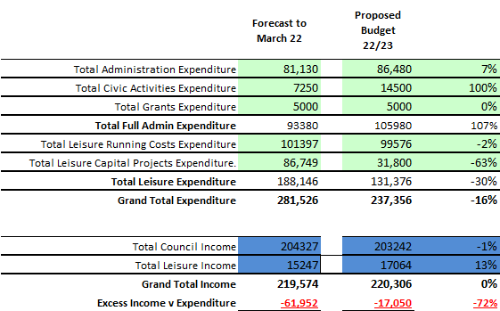
At this stage, the precept has been input as exactly the same figure as the current year and other income included on a best estimate basis.
Expenditure decreases significantly, mainly driven by Leisure Capital Projects where the Cheapside play equipment (£50k) is fully covered in the March 22 period and is not required budget. Administration expenditure increases mainly due to the full year effect of having three staff members. Civic activities are driven by the library contribution to£5k and a provision of £9k for the Platinum Jubilee Party in the Park, where no corresponding events have taken place for the past two years.
The overall result is that even though expenditure has fallen significantly, it would not be covered by income as currently stated. The shortfall could be covered by an increase in precept if agreed.
The overall reserves position is shown below. In addition to the required three months of expenditure reserve, specific provision is made for the Blythewood and Tom Greens management programs, 90 K is earmarked for South Ascot once the lease issue is resolved and the balance is available for unforeseen activities.
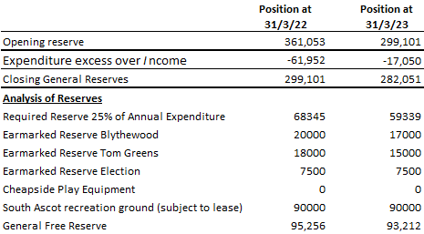

Formal motions will be put to the meeting to agree or otherwise the budget.
Subsequent to this meeting 11th January a proposal will be put to council to decide upon the precept level required to deliver the agreed budget.

R Wood 8/12/21

