**Leisure & Cultural Committee Meeting, 01 February 2022**

**Agenda Item 6 – Tennis & MUGA Court Fencing**

**Background**

The fencing around the tennis courts and MUGA court has been in a poor state of repair for some time and is increasingly deteriorating, causing a safety issue. Over the years the Weldmesh fencing has been repaired in several places, but the condition of the fencing overall has now moved beyond this option. In addition, the “hole” cut in the fence between the courts some time ago, to enable the retrieval of balls, has sharp edges and requires urgent attention/the installation of a gate.

Materials available for fencing have evolved in recent years and there are now different types of fencing which are more appropriate and hardwearing than the weldmesh that was originally installed.

Three quotes were sought for the work but, despite our best efforts, only two have been forthcoming.

**Proposal**

Recognising that the council has already budgeted £15,000 for court fencing repairs, to decide:

1. Whether to replace the fencing on both courts or just the MUGA court;
2. To accept one of the quotes.

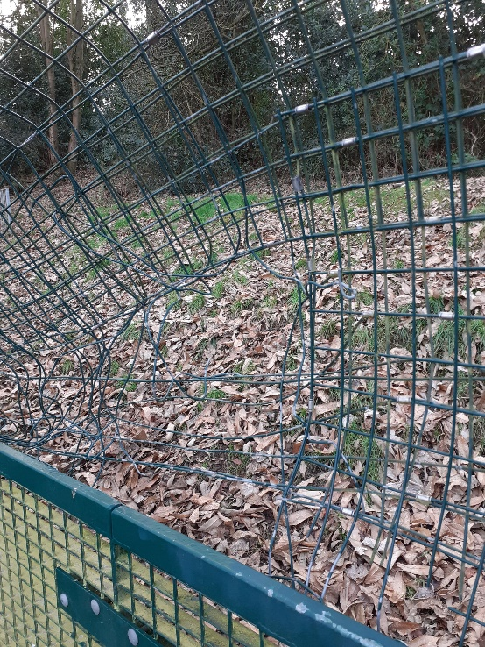

**Chiltern Sports**

**PROCTER CONTRACTS**



