AGREED BUDGET 22/23
At the previous meeting on 14th^{th} Dec the proposed budget was approved with the following additions to expenditure. Legal expenses were added in Admin £5k to cover possible costs re Coombe Lane and £3k provided in Civic Activities to cover the cost of giving a Platinum memento mug to all Primary School children. The result is that the excess of expenditure over income rises to £25k, assuming the precept were to remain at the previous absolute level.
Set out below is a summary resulting budget for next year (the circulated Excel file contains the detailed breakdown on a line-by-line basis)
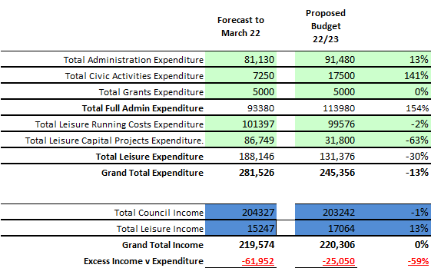
At this stage, the precept has been input as exactly the same figure as the current year and other income included on a best estimate basis.
Expenditure decreases significantly, mainly driven by Leisure Capital Projects where the Cheapside play equipment (£50k) is fully covered in the March 22 period and is not required in budget. Administration expenditure increases mainly due to the full year effect of having three staff members. Civic activities are driven by the library contribution to£5k and a provision of £9k for the Platinum Jubilee Party in the Park, plus the £3k mugs detailed above, where no corresponding events have taken place for the past two years.
The overall result is that even though expenditure has fallen significantly, it would not be covered by income as currently stated.
The shortfall could be covered by an increase in precept if agreed to deliver a balanced budget.
The effect on reserves will be detailed after the decision on Precept is agreed.
Formal motions will be put to the meeting to agree the precept level.
R Wood 16/12/21

