Extraordinary Council Meeting

As outlined at the full Council meeting on 14th December, the CIL working group had reviewed various proposed projects, one of which related to Charters School where a request had been admitted for the creation of an external area canopy for the 6th form.
At that stage it was decided that the project with a value of £25,600 was a significant sum and that whilst Sunninghill and Ascot Parish Council supported the proposal and could fund the project, it would be better if this project was jointly funded with Sunningdale Parish, especially as the school is in their parish.
The outline of the project was detailed to the meeting on 14th December and that the project would be brought back to the Full Council, if Sunningdale agreed to jointly fund. At a meeting on 18th Jan Sunningdale Council agreed to fund 50%. Unfortunately, the meeting on 23rd March is the Annual Assembly and as such cannot conduct any other business and no further meetings beyond this have been set. For this reason, an Extraordinary Council meeting is scheduled for 1 February at 6.30 prior to the Leisure and Cultural meeting
The background to the proposal is that the sixth form has expanded beyond the initial expectation of 240 and currently it has over 400 students. Pressure exists on internal locations due to the number of students and an external area adjacent to the sixth form block is felt beneficial. The area is proposed for
- Additional dining space.
- Breakout areas for students, especially during inclement weather
- Outdoor classroom.
- Outdoor performance area.
All of this is envisaged against the background of ongoing Covid-19 infections and the utilisation of fresh air to limit the transmission.
Below are pictures of the type of construction that will be created and the area within the school which is envisaged for use.
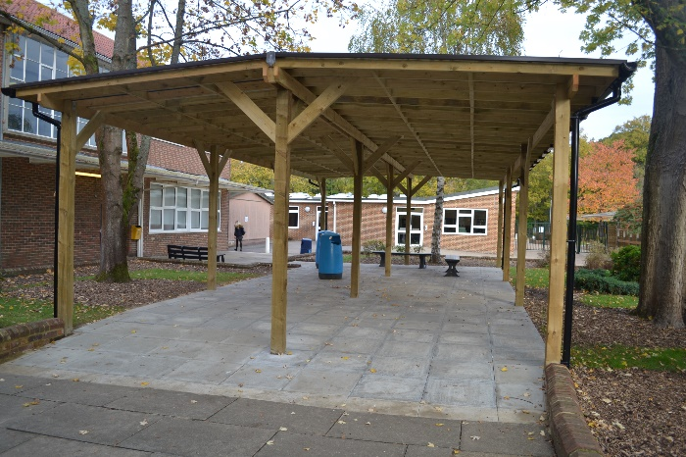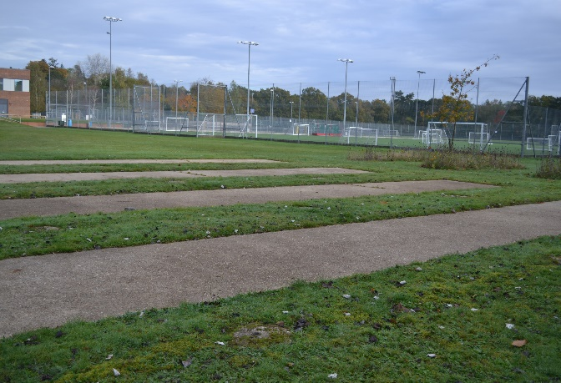
The proposal to be put to the Council is.

Agree to fund 50% of the outdoor facility at Charters School 6th Form in the sum of £12,600.
There are sufficient funds to cover this project in the C I L reserve and the remaining total within reserves will be in excess of £800,000 and the project is one which is expected within legislation as being investment in Infrastructure to offset the effects of developments within the Parish.

