Planning Application 22/01431 - 1, Kings Road Sunninghill

Sunninghill and Ascot Parish Council’s response to the above planning application.

Our parish council is deeply concerned at the designs put forward by Wooldridge on many counts as they fail to comply with many of the policies of the applicable made planning documents, including the recently adopted Borough Local Plan (BLP), Sunninghill and Ascot Neighbourhood Plan (AS&S NP) and the RBWM Borough Wide Design Guide (BWDG).

It is the wrong development in the wrong location and we strongly recommend refusal, for the reasons we set out below:
- Summary of primary objections:
- The applicant hasn’t consulted with the community on the current proposals, as required by the guidance in table 2.1 and in table 4.1 step 3, engagement, of the RBWM Borough wide Design Guide.
- The proposal represents a significant over - development of the site and doesn’t respect the building lines in Kings Road or the High Street.
- The development fails to respect the Victorian character of its immediate setting and of the wider village, as required by NP/DG1.4 – Respecting the Townscape and by Objective 1ii section 4.3 of the Local Plan – Special Qualities.
- The design of the proposed building doesn’t respect the grain, layouts, rhythm, density, skylines, scale, bulk, massing, proportions and footprint of the local built and natural environment, or with the Village as a whole, as required by policies QP3.1b, NP/DG2.1 and principles 7.6.1 and 7.6.2 of the Borough Wide Design Guide.
- The food retail store is too large for the small village and is unnecessary as the local needs are met by the two existing convenience store and another due for opening soon (ref: LP Policy TR5).
- The proposals severely damage the setting of the historic Cordes Hall by virtue of its sheer scale, mass and style, masking the valued views of the Cordes Hall when entering the village from the north and the backdrop of trees when viewed from School Road and the High Street, contrary to LP policies HE1 and HE1.2, QP31b and 1f, and NP policy NP/DG4.
- The proposal fails to deliver the required private and communal amenity space for flats as required by LP policy QP3.1 l and Principles 8.5.1-8.5.4 and 8.5.6 of the Borough Wide Design Guide.
- The applicant is not proposing to provide any affordable homes, as required by LP policy HO 3.5b, on viability grounds.
- The on-site parking provision is inadequate, with a deficit of 15 parking spaces, and isn’t in accordance with the RBWM parking strategy for a location poorly served by public transport and with policies NP/E3.2(b), NP/T1.1.and 1.2 and NP/SV1.1, 1.2 and 1.3.

We have reviewed the Planning Statement contained in section 9 of the Design and Access statement and consider many of the policy responses are seriously flawed and should be disregarded.

- Context:

Sunninghill is an attractive and vibrant Victorian village of great character and is much loved by residents and visitors alike. The good variety of retail and services, mostly small independents, makes it a popular destination.
The downside is that it suffers from a severe deficit of parking and the High Street is frequently congested. The Village is a popular cut through from the A329 London Road to the A30 south of the village and to the A30 at Sunningdale via Sunninghill Road and Kings Road. This causes congestion at the junction by the site, exacerbated by the on-street parking in the High Street and Kings Road, which effectively reduces them to a single lane.

The village has 2 convenience stores very close to the proposed development. A third, larger store, at the south end of the High Street has been completed but isn’t yet trading.

There is a buoyant night-time economy, due to the 4 restaurants and a take-away close to the site, events at the Cordes Hall and after school activities at St. Michael’s School.
The Cordes Hall is home to the Quince Players and Spotlight drama groups, a community cinema and other community activities, all of which add to the parking problems and extend them well into the evening.
There are two landmark buildings in the village, the historic Cordes Hall and St Michael’s Primary School. Landmark views include the school and views across the school playground towards the High Street, Cordes Hall and the development site, and to the Library and The Terrace. A feature of the Village is the backdrop of trees and are a strong feature on the skyline in views from School Road and the High Street towards the Cordes Hall and the site.
The development is on a prominent busy corner position at the northern gateway to the High Street and lies opposite the Cordes Hall, an attractive historic building. Its design therefore needs to be sensitively handled so it fits comfortably into this setting and is in harmony with and respectful of its surroundings.

- Outline of Development Proposals:
The development It is at the north end of the commercial area of Sunninghill village, a Local Centre, but is separated from the rest of the centre by Kings Road. It lies within the RBWM Townscape Assessment Classification 5D - Victorian Villages (ref: Fig 3.7, vol 3 of the Townscape Assessment). The proposal is for 14 flats and a 328 sqm food retail store. The residential density is 79dph.

The building is a 3-story contemporary building with an unbroken frontage of 60m on Sunninghill and Kings Roads. The building façade is mostly set just 1m from the highway. The prominent NW and SW corners are set forward and rise over 10m above the highway. The 2nd Floor is set back 1.3m from the main frontage, but the benefit of this is largely offset by the solid perimeter parapet and the roof overhang of around 0.5m.
The building will block most of the landmark view of the historic Cordes Hall (1902) from the Sunninghill Road when entering the village from the north, and when viewed from School Road it masks the backdrop of trees to the Cordes Hall (ref:?).
There are 23 parking spaces for the 14 flats, a deficit of 4, and 11 for the food retail, a deficit of 11, giving a total deficit of 15 spaces.
- Detailed Objections:
- Limited community involvement contrary to the guidance in table 2.1 and in table 4.1 step 3, engagement, of the RBWM Borough wide Design Guide.
The developer conducted a limited consultation in or around August 2021, but the application doesn’t include a consultation report. Since this consultation the character of the development has changed significantly, from a style that sought to respect the local character to a contemporary design, which is at total variance with the local character. This change was made without any community engagement or consultation despite the site being in a very visible location and opposite the Cordes Hall, an Historic community building,
- The proposals represent significant over-development of the site.
The residential density, at 79dph, is over 64% higher than recommended in the HELAA for the site (48dph) and there is inadequate external space to accommodate the required parking, external shared community amenity space, essential external M&E equipment or trolly storage.
The building extends some 7m forward of the building line on the north side of Kings Road and approx. 2m forward of the building line on the east side of the High Street, contrary to policy NP/DG 2.2a.

- The size of the food retail store is too large for the small village of Sunninghill and contrary to the intent of local plan policy TR5.
Local Plan Section 9.12.1 Local Centres states: “in general (Local Centres) include a range of small shops serving a localised catchment. Typically, they may include a convenience store, newsagent…(etc)”.
Local Plan policy TR5 states: “local centres will be supported to provide a wide range of services for their local community, mainly serving specialist needs or immediate needs of their local area”.
Paragraph 3.53 of the Transport Statement claims the store will have a small catchment area, with adjacent areas each having larger stores, and hence is considered unlikely to attract a large proportion of entirely ‘new’ shopping trips.
The village already has two convenience stores close to the proposed development and a third, at the south end of the village, is awaiting occupation. The immediate needs of the area are therefore well served and give customers a good choice. A fourth larger food retail store is both unnecessary and inappropriate for the size of the local catchment of Sunninghill.
- The development fails to respect the Victorian character of its immediate setting and of the wider village, contrary to NP/DG1.4 – Respecting the Townscape and to Objective 1ii Special Qualities, section 4.3 of the local plan
Appendix A shows the buildings immediately around the site, and it is clear that the new building is very far from respecting the townscape of Sunninghill.
Paragraph 3.30 Volume 3 Section 3 of the Townscape Assessment – Sunninghill and South Ascot, sets the following strategic principles to be taken into account in the development design process:
30.50.1 “The conservation of the well wooded ‘sylvan’ character of Sunninghill….”
30.50.9 “The Conservation of the St. Michael’s C of E Primary School, historic Kingswick House, the Cordes Hall and the residences in the Terrace as landmarks in Sunninghill. Development should not detract from these buildings as landmarks”.
The proposals fail to respect these two strategic principles – see f, below.
The proposal is also contrary to Objective 1ii Special qualities, section 4.3 of the local plan which requires developments to:
‘Retain the character of existing settlements through guiding development to appropriate locations and ensuring high quality of design of new development”.
The village of Sunninghill is recognised as having special qualities, and this proposal is the wrong solution in the wrong location.
- The design of the proposed building doesn’t respect the grain, layouts, rhythm, density, skylines, scale, bulk, massing, proportions and footprint of the local built and natural environment, or with the Village as a whole, as required by Local Plan policy QP3.1b, Neighbourhood Plan policy NP/DG2.1 or the RBWM Borough Wide Design Guide Principles 7.6.1 and 7.6.2 (Scale and Massing)
The High Street and buildings surrounding the site are nearly all Victorian in style, with gables or ridged roofs and of modest size (see Appendix A).
The Buildings in the east side of High Street are two story and semi-detached, and views of trees can be glimpsed down many of the alleyways. Their frontages and roof lines are varied and interesting. The Cordes Hall and Novello Theatre are both single story. St Michael’s school, also single storey, lies to the west of the High Street but set well back.
The residential buildings on the S side of Kings Road are also Victorian semi-detached dwellings with varying frontages and roof lines. Those more recent dwellings on the north side are 1 story (next to the site) or 2 story.
It is abundantly clear that the proposal is way beyond anything else in the village in terms of grain, layout, rhythm, density, scale, bulk, massing, proportions and footprint.
The following extracts from the developers Design & Access (D&A) Statement (Pages 15 and 25) and the photographs on Appendix A clearly show that the proposals will dominate the Cordes Hall, bungalow in Kings Road and cottages on the west side of Sunninghill Road

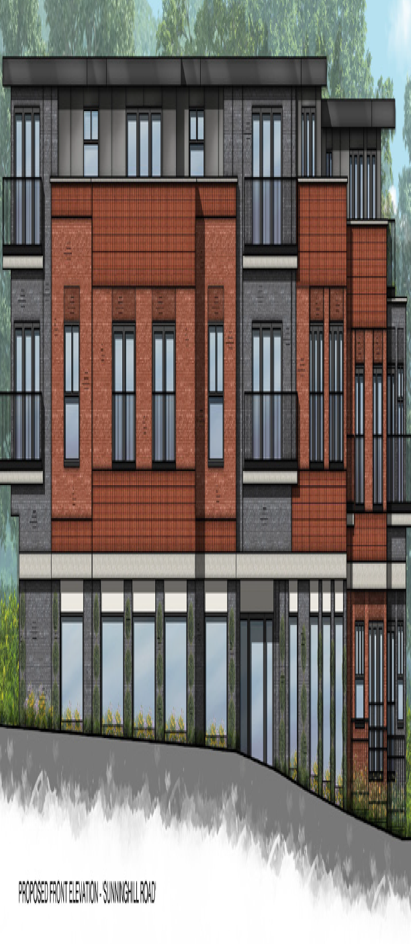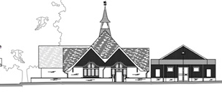

.
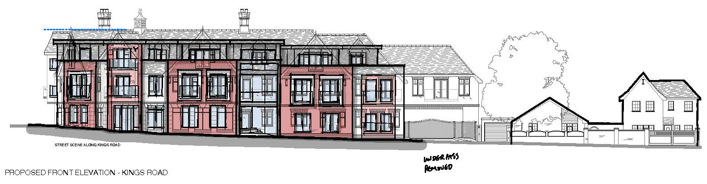

- Contrary to Local Plan policy HE1.1 and HE1.2. Historic environment, and LP policy QP3.1f, and not in line with the Townscape Assessment development strategic principles for Sunninghill.
- HE 1.1 states that the “historic environment will be conserved and enhanced in a manner appropriate to its significance. Development proposals would be required to demonstrate how they preserve or enhance the character, appearance and function of heritage assets (whether designated or non-designated) and their settings and respect the significance of the historic environment”.
- HE1.2 states that “Heritage assets are an irreplaceable resource and works which would cause harm to the significance of a heritage asset (whether designated or non-designated) or its setting, will not be permitted without a clear justification in accordance with legislation and national policy”.
- QP3.1 sets principles for development to ensure it achieves sustainable high-quality design. Relevant principles include:
- QP3.1 b “Respects and enhances the local, natural or historic character of the environment” and
- QP3.1f “Retains important local views of historic buildings and features.
- Paragraph 3.30 Volume 3 Section 3 of the Townscape Assessment – Sunninghill and South Ascot, sets the following strategic principles to be taken into account in the development design process:
- 30.50.1 “The conservation of the well wooded ‘sylvan’ character of Sunninghill….”
- 30.50.9 “The Conservation of the St. Michael’s C of E Primary School, historic Kingswick House, the Cordes Hall and the residences in the Terrace as landmarks in Sunninghill. Development should not detract from these buildings as landmarks”.

- Objective 1iii – Special Qualities of the Local Plan’s Strategic Objectives requires developers to “Protect the special qualities of the built environment including heritage assets.

The development clearly doesn’t comply with any of the above policies and principles. For example:
- Due to its height, footprint, bulk, scale and mass, and its position very close to the highway the proposed building will dominate the Cordes Hall and damage its setting.
- When entering Sunninghill from the north there is an early view of the whole of the Cordes Hall. The proposed building will block most of the view until the junction with King’s Road is reached.
- The building will also block the view of important trees as shown in Appendix B. When viewed from School Road and the High Street the Cordes Hall is framed by a backdrop of trees. The new building will largely hide these and will thus damage its setting. At present many of the views across the site include a backdrop of trees, most of which will become hidden by the new development.
- The proposals fail to deliver the amenity space requirements contrary to LP policy QP3.1l and Principles 8.5.1 – 8.5.4 and 8.6 of the RBWM Borough Wide Design Guide.

QP3.1l requires developments to provide sufficient levels of High Quality private and public amenity space. It doesn’t provide for this being off site, as proposed by the applicant.
8.5.1 states that flatted developments will be expected to provide high quality outdoor space for each unit.
8.5.2 defines the requirements for ground floor flats in relation to size and boundary treatments. Both the ground floor flats have inadequate amenity space and front directly onto public space – one is within a meter of Kings Road, and will be materially affected by noise and pollution, contrary to 8.5.4. It also poses a security risk.
8.5.3 defines the balcony requirements for flats above the ground floor. The balcony depths are within the range of 1 to 1.5 m deep whereas the minimum required depth is 2.0m
8.6 defines the communal outdoor amenity space requirement as 10sqm per flat, or 140 sqm in total. The community amenity space provided is only 19 sqm (the size of 1.5 parking spaces). It isn’t connected to the building or screened from the public, lies directly alongside the HGV delivery bay (for vehicles up to 12m in length) and is close to the resident’s parking bays.

- Contrary to LP policy HO3.5b. – Affordable Housing.
The developer doesn’t propose to provide any affordable Housing, citing financial viability. A viability report is included in the application. We find it difficult to understand how a small site such as this with a residential density of 79 dph and a 328 sqm supermarket can be unviable but leave it to the Borough to ensure its policy is rigorously applied. We note the lack of new sites for affordable homes in our Neighbourhood Plan area, and it is therefore important they are provided on site.
Strategic
Objective 2iii of the recently adopted local plan is to “provide housing to meet the needs of all sections of the community including a sufficient level of affordable home”’.
This is to deliver the Strategic Plan themes: Residents first, Value for money.

- The Parking provision is below the maximum provision in the RBWM parking strategy (2004) and does not comply with policies NP/E3.2(b), NP/T1.1.and 1.2 and NP/SV1.1, 1.2 and 1.3.
The application claims that the location is between good and poor accessibility. As the stations of Ascot and Sunningdale are much further than 800m from the site [1.8 and 2.1m respectively] and the No 1 Bus service is infrequent [8 in each direction on weekdays, 6 on Saturdays and none on Sundays) the site clearly has poor public transport accessibility. The maximum residential parking requirement is for 27 spaces [ref 23 provided, and for the food retail is 23 parking spaces [ref 11 provided], a total deficit of 15 on-site parking spaces.
In paragraph 284 of her final report on her BLP examination the inspector stated:
‘The 2004 Strategy sets maximum (parking) standards, and while MM46 requires some flexibility in their application would be contrary to the Plan’s own intention to move to minimum standards. It would also be contrary to the Government’s statement in March 2015 that the imposition of maximum standards led to blocked and congested streets and pavement parking, and the market is best placed to decide if additional spaces should be provided. I have therefore amended the wording of the modification to clarify that while the 2004 strategy can be used as a guide to the appropriate level of parking, it should not be used to set a maximum level’.
Policy NP/SSV1.1 was included in the NP because of longstanding parking and congestion problems in the village, extending over 20 years. Parking studies in the village clearly demonstrated the problem, and in consultations show parking is at or close to the top of residents list of concerns.
We don’t recognise the results of the parking surveys included in the Transport Statement and will be responding separately on this matter.
- Other Concerns:

- The developer hasn’t demonstrated how his design has addressed the Council’s 4 strategic Themes, contrary to BWDG Principle 3.1 and in particular, putting people first.
- The landscaping and Ecology Masterplan shows that the only access to the food store from the car parking is a 1.2 m wide pavement by a busy road, clearly a safety hazard.
- The swept path analyses for an 11m pantechnicon and a refuse vehicle are shown on Drawings 21.126-001 and 002 of the Transport Statement. Both show that it is necessary for the vehicles to reverse approx. 11m into the Residential Parking area, which is unacceptable. The pantechnicon swept path also is very close to both the residential and retail parking bays, leaving no room for error.
Both the analyses show the vehicles entering from the north but don’t show either of them entering from the south or leaving in either direction. No sightlines are shown but when exiting onto the Sunninghill Road the sightline to the north looks sub-standard.

18th June 2022.

APPENDIX A: CHARACTER OF AREA CLOSE TO THE SITE:
View from High Street towards Cordes Hall.

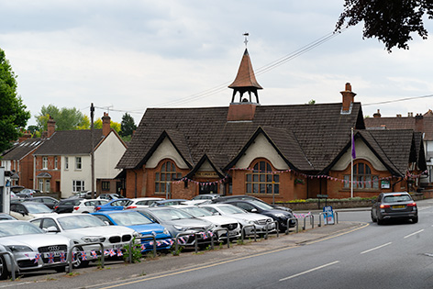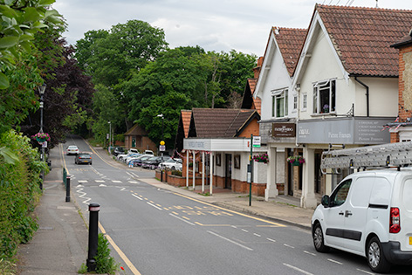
View from Sunninghill Road towards Cordes Hall.

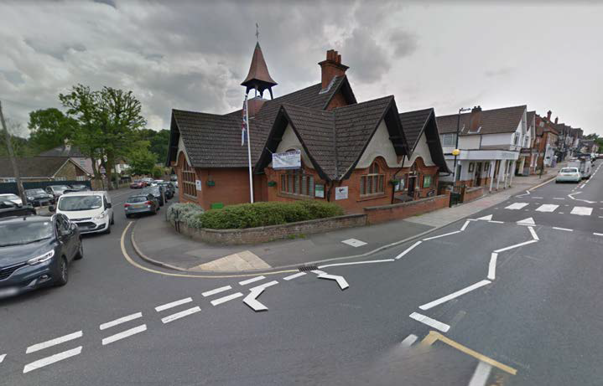
View from Sunninghill Road / Kings Road Junction towards Cordes Hall.

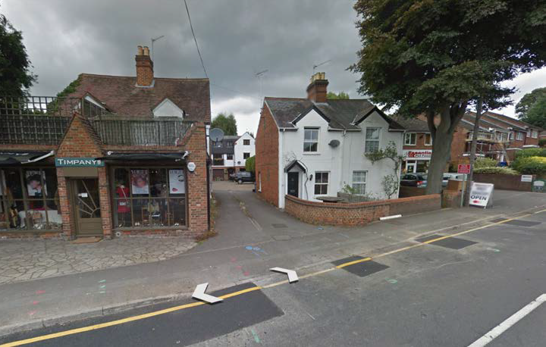
View from the development across the Sunninghill Road

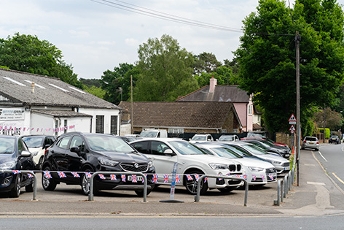
View from Sunninghill Road towards the new development and Kings Road.
.

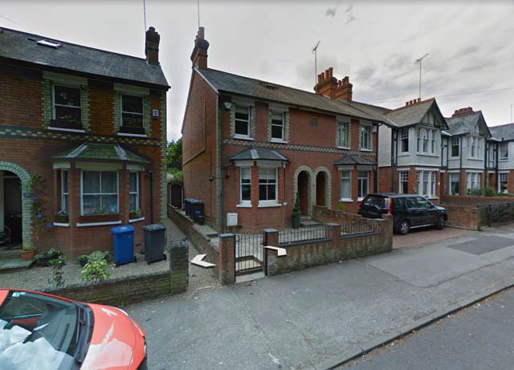
View of the S side of Kings Road looking towards the Cordes Hall

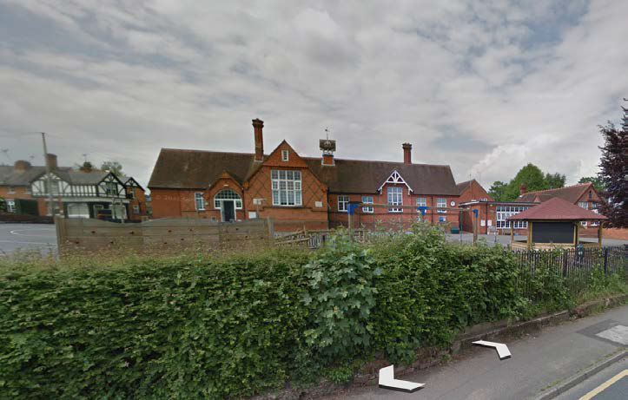
View of St Michael’s School from the High Street

APPENDIX B. APPROX VIEWS BLOCKED BY DEVELOPMENT

