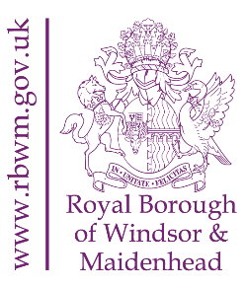

Notice of Interim Review of Polling Places

Notice is hereby given that, in accordance with the Polling Districts and Polling Places (Parliamentary Elections) Regulations 2006, the Royal Borough of Windsor and Maidenhead (RBWM) is conducting an interim review of Polling Places within Polling Districts in the following wards:

- Bray
- Furze Platt
- Pinkneys Green
- Riverside
- Ascot and Sunninghill
- Clewer and Dedworth West
- Clewer East
The interim review is to consider the suitability of Polling Places in meeting the needs of electors where a temporary Polling Place was used for the Police and Crime Commissioner (PCC) elections in May 2022 due to the impact of the Covid-19 pandemic, and consideration as to whether the temporary Polling Place should be designated as a permanent Polling Place for all future elections. The comments of the RBWM (Acting) Returning Officer on proposals to designate new Polling Places are contained in the appendix.

The Council welcomes comments from interested parties including any resident, the MPs for the Maidenhead and Windsor constituencies, any RBWM Councillor (in particular those representing electors within the above wards), election agents, local political parties, and past or potential candidates. We also welcome views from individuals and organisations who may have particular expertise in relation to access to premises or facilities for persons who have different forms of disability.

The consultation period will commence on Monday 22 August 2022 and all representations must be received by Monday 3 October 2022. Representations should be made in writing by emailing: pd.review@rbwm.gov.uk or by post to: Electoral Services, Town Hall, St Ives Road, Maidenhead, SL6 1RF.

All representations will be published on the Interim polling district and polling places review webpage, which can be found by navigating to https://www.rbwm.gov.uk/elections, as soon as possible, after receipt; even if an individual or organisation has already commented on the proposals, they may make further submissions in response to views and comments on the website. Anyone making representations is requested to suggest alternative Polling Places to those proposed where appropriate, and to give reasons for the alternative.

Following consideration of all representations received during the consultation period, final proposals will be considered at the Full Council Meeting on 22 November 2022.

Emma Duncan
(Acting) Returning Officer
Royal Borough of Windsor and Maidenhead
Town Hall
St Ives Road
Maidenhead
SL6 1RF

22 August 2022

