Your attendance is requested at a meeting of the CIL Committee
to be held on Wednesday, 30 August 2023 at 7.00pm
in the King Edward VII Meeting Room, Ascot Racecourse, SL5 7JX

Members: Councillors L Davison West, J Gripton, B Hilton, D Hilton, C Richardson, C Roberts, A Sharpe, B Story, R Tavoletti, M Turton, R Wood.
To: Other Members of the Parish Council for information only.

A G E N D A

- APPOINTMENT OF CHAIRMAN AND VICE-CHAIRMAN
To appoint the Chairman and Vice-Chairman and to receive their Declarations of Acceptance of Office.

- TO NOTE APOLOGIES FOR ABSENCE
3. DECLARATIONS OF INTEREST
To receive any Declarations of Interest in accordance with the adopted Code of Conduct.
4. REVIEW OF TERMS OF REFERENCE FOR THE COMMITTEE
To review the committee of the Terms of Reference as ratified by full council in June 2023.

5. POLICY AND PROCEDURE
To ratify the Policy & Procedure of the committee as agreed by full council in July 2021.

6. DISCUSSION ON POSSIBLE PROJECTS
For members of the committee to bring forward ideas on possible projects for discussion.

7. DECISION ON PROJECTS TO BE EVALUATED AND BY WHICH COMMITTEE MEMBER
To allocate projects to individual committee members for evaluation

8. DATE OF NEXT MEETING
To agree the next date for the committee to meet.

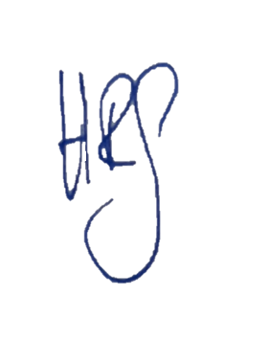

Helen Goodwin

Clerk to the Council
23 August 2023

