Your attendance is requested at a meeting of the CIL Committee
to be held on Wednesday, 27 September 2023 at 7.00pm
in the King Edward VII Meeting Room, Ascot Racecourse, SL5 7JX

Members: Councillors R Wood (Chairman), R Tavoletti (Vice-Chairman), L Davison West, J Gripton, B Hilton, D Hilton, C Richardson, C Roberts, A Sharpe, B Story, M Turton.
To: Other Members of the Parish Council for information only.

A G E N D A

- TO NOTE APOLOGIES FOR ABSENCE
2. DECLARATIONS OF INTEREST
To receive any Declarations of Interest in accordance with the adopted Code of Conduct.
3. UPDATE ON OVERALL EXPECTED FUNDING
Update on overall expected incoming funding over the next 7 years, plus possible phased spending over major portfolio. Cllrs Wood and Tavoletti to provide.

4. VICTORY FIELD UPDATE
Cllr Davison West to provide update on the use of consultants to outline alternatives to be considered for Victory Field.

5. UPDATE ON PROJECTS ALLOCATED TO RELEVANT COUNCILLLORS
Update by councillors on activities allocated to them.

6. DATE OF NEXT MEETING
To agree the next date for the committee to meet.

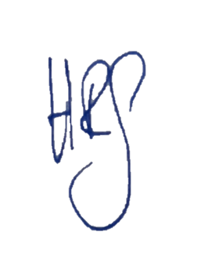

Helen Goodwin

Clerk to the Council
20 September 2023

