Minutes of a meeting of the CIL Committee
Held in the King Edward VII Meeting Room, Ascot Racecourse, SL5 7JX
On Wednesday 31 January 2024 commencing at 7pm

Members present: Councillors R Wood (Chairman), R Tavoletti (Vice-Chairman), L Davison West, J Gripton, B Hilton, D Hilton, C Richardson, D Sanders & B Story
In attendance: O Marsden, Project Administrator, Parish Council

8684 APOLOGIES FOR ABSENCE
Apologies were received from Cllr A Sharpe and accepted by the committee. Cllrs C Roberts and M Turton were absent.

8685 DECLARATIONS OF INTEREST
The Vice-Chairman asked to receive any Declarations of Interest in accordance with the adopted Code of Conduct. None were received.

8686 MINUTES
The minutes of the CIL Committee meeting held on 05 December 2023 were approved as a correct record and signed as such.

8687 UPDATE ON STATUS OF COUNCILLOR PROJECTS
- Paths and Rights of Way (RT): Cllr Tavoletti outlined the project to improve the paths and rights of way (PROW) in our parish. A meeting has been held with the Parks & Countryside Team at RBWM to discuss maintenance of all the paths, and a schedule has been circulated. The next step is to appoint councillors to walk the paths and record their condition, and then feed this information back to the SAPC office. It was agreed that this would be discussed at the next Leisure & Cultural Committee meeting when volunteer councillors would be chosen. There was discussion about the issue of dog waste bins and the problems of installing and emptying bins on path no. 7. These are currently the responsibility of RBWM. It is unclear whether the current contractors for emptying the dog bins (Shorts) could also take on extra work. Cllr Tavoletti raised the issue of the proposals to extend path no. 13. At this stage stakeholders are still being identified and the costs of realising such a proposal need to be fully fleshed out.
- Cemetery (AS): no update as Cllr Sharpe was absent.
- Electric Vehicle Charging (RW): Cllr Wood is due to hold a meeting with the Racecourse, and will update the CIL Committee at the next meeting.
- Victory Field (L DW): Cllr Davison West gave an update on the Victory Field project. The Project Centre (consultants carrying out the feasibility study) have delivered initial designs for the project, which were shared at the recent Leisure & Cultural Committee meeting. The consultants are now delivering stakeholder workshops and developing two masterplans, before submitting their feasibility report to SAPC officers and project councillors on 18 March.
- There was discussion about the proposed parish map and the 20 mph consultation. Cllr Richardson will update future meetings as to whether any funding might be required for these but the timing is expected to be over 12 months away.

8688 INSIDE SPACE STRATEGY
The issue of whether an Inside Space Strategy is required was discussed; this would complement the proposed Green Space Strategy for the parish, which is in the process of being developed.
Inside spaces include all buildings which are in public use, such as Cordes Hall, the Day Centre, Scout Halls, Church Halls etc. It was suggested an audit of all buildings and spaces belonging to the parish council should be carried out, to gain a greater understanding of what could be used within the Parish. Cllr D Hilton reminded the committee that work had been done on this previously, some years ago.

It was agreed that Cllr B Hilton would work with officers to produce details such as space size, days available, major users and any restrictions (e.g. not available in evenings for adult parties).

8689 POTENTIAL FUTURE ACTIVITIES
Cllr Tavoletti presented his backing paper, CIL Portfolio Status and Recommendations, January 2024. It was strongly felt that there was an urgent need to decide on which projects to move forward with, in order to avoid stagnation.
It was stressed that it would be sensible not to undertake too many projects at any one time, and to choose which projects are the highest priority. Cllr Tavoletti suggested that one project be assigned to one councillor, then to liaise with the SAPC office.
Cllr Davison West pointed out that the appropriate CIL paperwork must be completed before any physical work physical can be carried out.
Cllr Davison West believed that South Ascot recreation ground should be on the priority list.
There was considerable discussion about the listed projects:
- Sunninghill congestion relief: RBWM Highways will not undertake this project. Investigations have been conducted into parking and traffic issues on Sunninghill High Street, and what can be done to alleviate these. Cllr Wood agreed to document the background to previous attempts to alleviate congestion.
It was highlighted that HGV vehicles could not be restricted as the low bridge in South Ascot forces vehicles to use Sunninghill.
Cllr Richardson pointed out that the area as a whole needs to be looked at, from Church Lane all the way down through Sunninghill high street.
- Enhance footpaths at St George’s Lane (paths 24 & 10): Cllr Tavoletti to investigate.
- Electric minibus shuttle: Cllr D Hilton to provide background info to Cllr Sanders to look into this.
- Parking surveys Sunninghill: Previous investigations have been carried out. Cllr Wood will investigate the requirements as part of the Neighbourhood Plan revision.
- Youth club: Cllr Davison West to take on the investigation on this project as she has previous knowledge of activities that have been carried out.
- Buy land west of St George’s Lane for footpath: Cllr Wood advised that any decisions on this project should be held off until a decision is made regarding the Coombe Lane Village Green site. Cllr Richardson happy to take on this project when decisions are made.
- Tom Green’s Field extension: Cllr Wood to investigate possible options re this land to the south west of TGF but whose ownership is unknown.
- South Ascot recreation ground: Cllr Richardson to take as a project.
- Ascot High Street: As part of the regeneration of the High Street and AL16 it may be that some funding is requested re Greening/Cycle ways, but the majority should come from Govt or RBWM own CIL funds.
- Sunninghill roundabout/Church Lane: as above.
- Exchange Road: This is highlighted as a cycle way improvement in the current Neighbourhood Plan. Cllr Richardson agreed to investigate further.
- Ascot to Heatherwood: forms part of the paths and rights of way project and is being investigated.
- Sainsbury’s multi-storey car park: Car parking facilities will be required as the High Street Plans move forward and acquisition of this asset may be part of this.
- Car park 6 replacement: Car parking facilities will be required as the High Street Plans move forward, currently CP 6 is used by High Street businesses and when the land to the north of the High Street is replaced by housing it is imperative that similar car parking provision is maintained.
- Kit out community centre/cinema: these proposals form part of the Ascot Rejuvenation Plans already underway, but as per the current proposals for a turnkey solution still require a full fit out and equipment provision.
- Cordes Hall: Cllr Gripton brought up the issue of the Novello Theatre. PC to understand what use is being proposed for Novello and its operational costs.
- Day Centre and St Michael’s playing fields: Cllr Roberts (absent at meeting) to investigate.

- It was agreed that the SAPC office would circulate a list of projects and appropriate councillors, once these have been received from Cllr Wood.

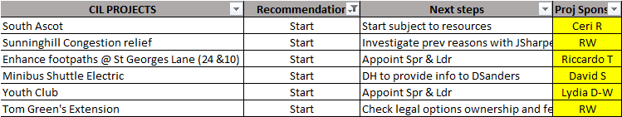

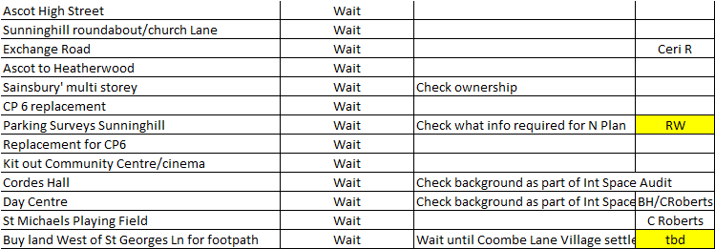

There being no further business the meeting closed at 8.35pm.

Robin Wood
Chairman, CIL Committee

