______________________________________________________________________________________________________

You are hereby Summoned to Attend

An Extraordinary Meeting of Sunninghill & Ascot Parish Council

to be held on Tuesday, 25 June 2024 at 6.45pm
in St. Michael’s Church Hall, St Michael’s Church, Church Lane, Sunninghill, SL5 7DD

TO: Members: Councillors A Sharpe (Chairman), B Hilton (Vice-Chairman), P Carter, L Davison West, J Gillborn, J Gripton, C Herring, D Hilton, C Revilla, C Richardson, B Story, R Tavoletti, M Turton, S Verma, R Wood.
TO: Other Members of the Borough Council for information and Outside Bodies.

AGENDA

- TO APPROVE APOLOGIES FOR ABSENCE
To receive and approve any apologies for absence.

- DECLARATIONS OF INTEREST
To receive any Declarations of Interest in accordance with the adopted Code of Conduct.

- END OF YEAR EXTERNAL AUDIT RETURN 2023/24
Members will be asked to approve the External Audit documents 2023/24:
  - Annual Governance Statement, Section 1.
b. Statement of Accounts, Section 2.

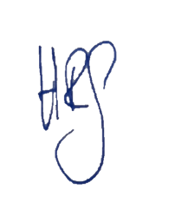

Helen Goodwin
Clerk to the Council

18 June 2024

