The Role of the Parish Councillor

A parish councillor is an elected, or co-opted, member of a parish council, which is an authority that makes decisions on behalf of the people in the parish. It is the level of local government closest to the community, with the borough council (in our case, the Royal Borough of Windsor and Maidenhead) above it in the hierarchy.

Role

A councillor’s role can include developing strategies and plans for the area, helping with problems and ideas, representing the community, working with other local community groups, decision making and reviewing decisions and talking to the community about their needs and what the council is doing.

Responsibilities

The Parish Council has responsibility for:
- Running local services within the parish. In Sunninghill & Ascot these include: Victory Field recreation ground, Tom Green’s Field, Sunninghill Cemetery, Cheapside allotments, Cheapside play park, South Ascot recreation ground, Blythewood play park & woodland.
- Deciding on how much to raise through the council tax in order to deliver the parish council’s services.
- Influencing and shaping the long-term development policy for the parish and, as part of the planning process, commenting on planning applications in the parish.
- Improving the quality of life and the environment in the local area.
- Working to identify issues which are important to the lives of the residents of the parish.
- Working to bring about improvements through local projects, lobbying other service providers and working in partnership with other parishes and agencies.
In order to carry out these functions, Sunninghill & Ascot Parish Council has three committees – the Planning Committee, the Leisure & Cultural Committee and the Finance & Personnel Committee*- as well as various working groups.
Commitment
All parish councillors are expected to be on either the Planning or the Leisure & Cultural committee and to attend all full parish council meetings and the meetings of their chosen committee (apologies for absence may be given due to sickness, holiday or other reason to be agreed with the council). By legislation, all council and committee meetings are held face to face, although working group meetings, which are less formal and arranged on an ad hoc basis to suit members, may be held ‘virtually’. The meeting schedule is attached as an appendix to this document**; in the year from May 2024 there will be 7 Full Council meetings, 12 Planning Committee meetings, 6 Leisure & Cultural Committee meetings, and 4 Finance & Personnel Committee meetings.
A parish councillor would usually be expected to hold the position for four years, which is the period of time between elections, but often they choose to stay longer. Sometimes the parish council co-opts a member, for instance when a councillor leave mid-term, in which case the position is held until the next election when that councillor chooses whether they wish to continue by standing for election. The next elections for Sunninghill & Ascot parish council will be held in May 2027.

Eligibility
To be a parish councillor someone must be able to meet the criteria as set out in the nomination form, which are:

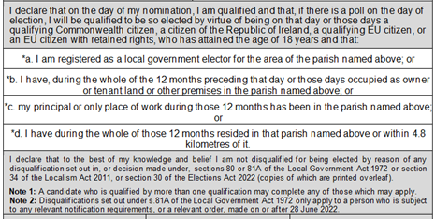

Sunninghill & Ascot Parish Council does not generally operate along party political lines. All parish councillors must sign up to the Code of Conduct, a copy of which can be found on our website

Becoming a councillor is a rewarding experience as you will be able to make a change in your community to help improve residents' lives. We do hope you choose to pursue this further and look forward to hearing from you.

APPENDIX 1 – MEETING SCHEDULE

